**1.3**

**Android Setup and Installation**

Generally to build an applications for Android we should have Java Development Kit (JDK), Android SDK, and a development environment.

The Android SDK is compatible with Windows, Mac and Linux operating systems to build android applications based on our requirements.

We can setup android development environment using following two ways

1. Setup Eclipse IDE Manually (**Depreciated**)
2. Android Studio

Initially Google supported a Manual **Eclipse IDE Setup** for android development environment by downloading required components like Eclipse IDE, Android SDK, Java Development Kit (JDK) etc. from official site. Afterwards Google introduced a component called **Android Studio** to make environment setup process simple.

By using **Android Studio** bundle we can easily setup android development environment in any operating system to implement android applications.

Android Studio is the combination of following components to allow users to implement android applications.

1. Eclipse IDE
2. Android SDK
3. Android Virtual Device
4. Eclipse Plugin

**Installation**

Initially to setup an android development environment in our system we need to install following components manually by downloading from different sites.

1. Eclipse IDE
2. Eclipse Plugin
3. Android SDK

To make android development environment setup process simple Google introduced a new android IDE called **Android Studio**. The **Android Studio** will contain all the required components like Eclipse IDE, Eclipse Plugin and Android SDK so we don’t need to download the components separately.

**Android Studio** is the official IDE for android development and it’s based on **IntelliJ IDEA** software. It’s available for Windows, MAC and LINUX operating systems.

We can download latest version of Android Studio from following URL.

[**Download Android Studio**](https://developer.android.com/studio/index.html)

In this tutorial we are going to explain how to install android studio on windows machine which is having windows 10 operating system.

Download the latest version of Android Studio from above URL and launch **Android Studio.exe** file by double clicking on it.

The initial android studio setup screen will open like as shown below in that click **Next** to continue for further steps of environment setup.

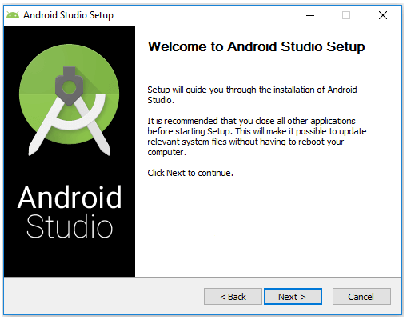

Now we need to select a required components to setup an android environment. Here we selected all three components (**Android Studio**, **Android SDK** and **Android Virtual Device**) and click **Next** like as shown below.

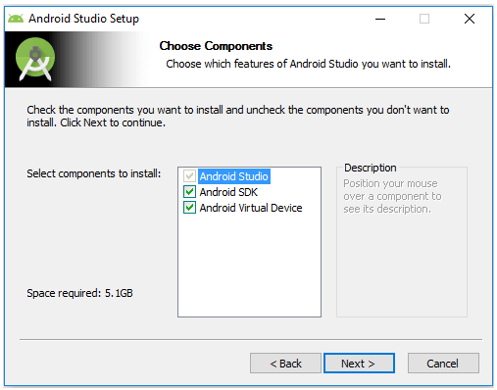

Now we need to agree the License agreements to proceed further, click on **I Agree** button like a shown below.

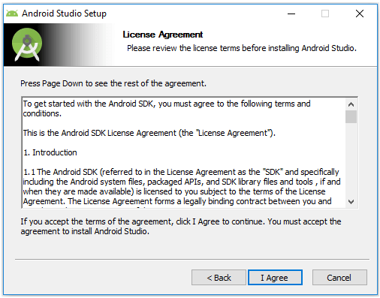

Now we need to specify the local machine drive location to install Android Studio and Android SDK. After selecting the location path to install required components, click **Next** like as shown below.

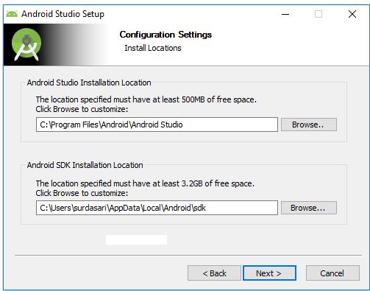

 Now select the start menu folder to create a shortcuts for android studio and click **Install** like as shown below.

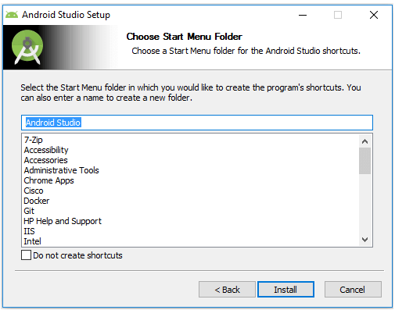

Once we click Install button the installation process will start and click **Next** after completion of installation like as shown below.

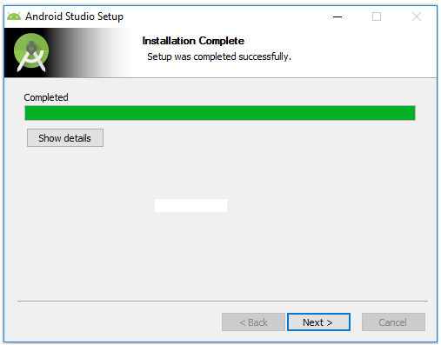

After that it will show installation completion wizard in that click **Finish** to launch android studio like as shown below.

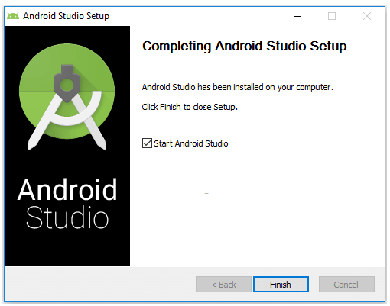

While launching **Android Studio** it will give us an option to import settings from previous version of studio. In case if we don’t have any previous version, select second option and click **OK** like as shown below.

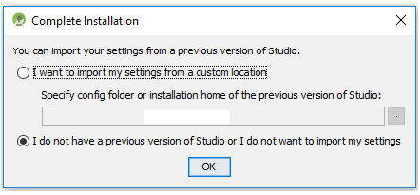

 Now android studio will open a welcome wizard window in that click **Next** to validate our current Android SDK and development environment setup like as shown below.

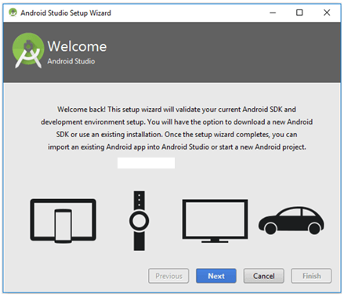

Now select a **Standard** installation type and click **Next** to install a common settings and options like as shown below.

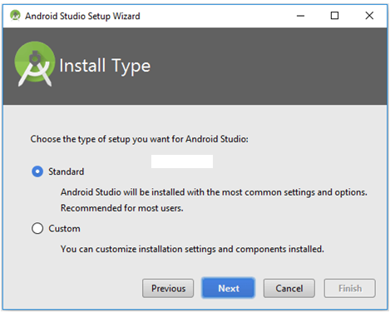

 Now verify settings and click **Finish** to complete android studio setup process like as shown below.

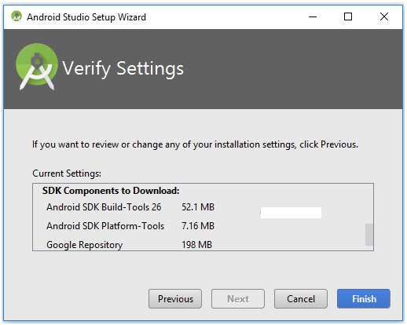

After completion of required components installation click on **Finish** like as shown below.

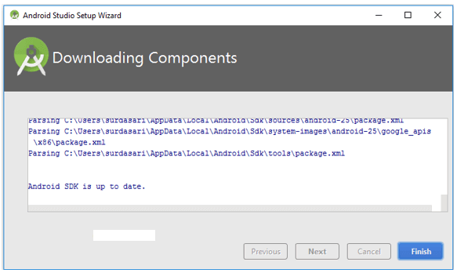

After completion of all required components installation we will be able to see Android Studio welcome window like as shown below.

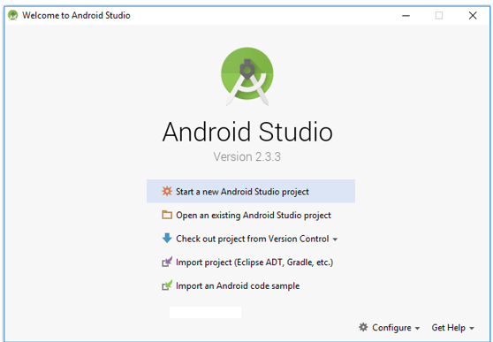

This is how we can setup android development environment on windows machine which is having windows 10 operating system using android studio IDE.

**Questions**

1. How many ways can be setup android development environment and what are the different components of Android Studio?